Early Irish Shoe Patterns
Lady Siobhán an Einigh of Connacht

Early Irish Shoe examples

Lucas Type 1: Lucas Type 2:
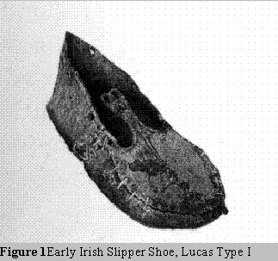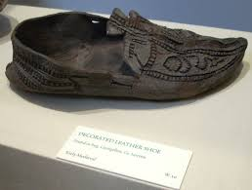

Pampootie/Curran/Bag shoe
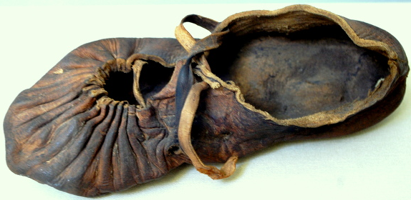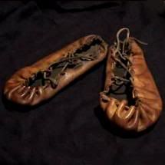

Lucas Type shoe in Book of the Kells (p29r)
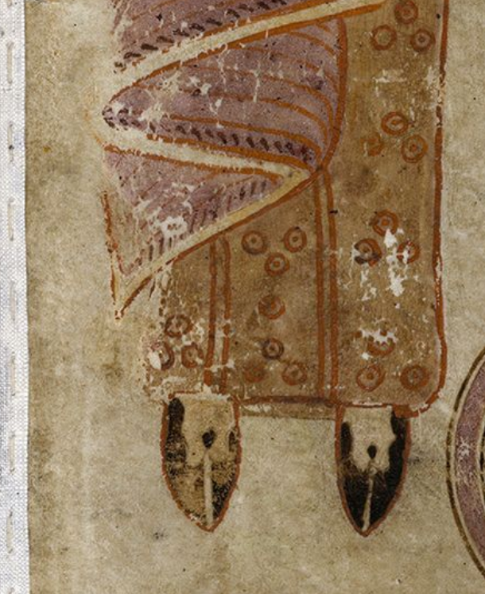

Marc Carlson’s drawings of Lucas shoes in pattern and put-together forms:
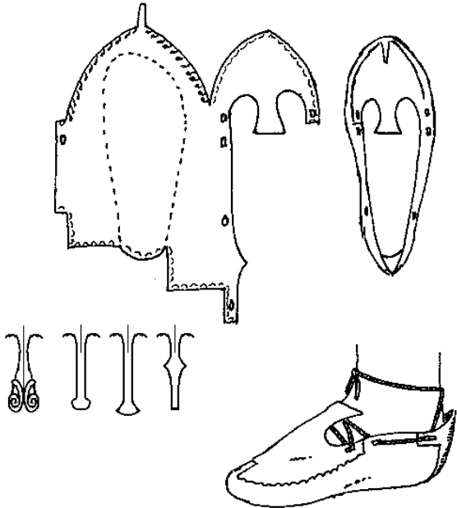 Type 1

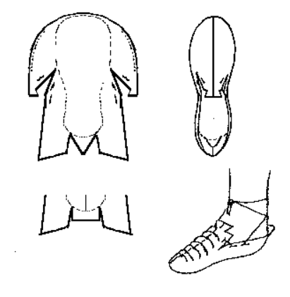Type 2
Notes on Using the Pattern:
1. Get a piece of shoe weight leather, large enough for the entire canvas pattern for both feet. As this is a one-piece shoe, you will want a heavy weight leather to ensure durability.

2. Trace around the canvas and cut out the pattern for each shoe. There is some debate on if the shoes were made with flesh out for better traction or flesh in for durability. I personally make them flesh in.

3. Mark/awl your sewing holes along the edges of the leather, following the drawings on the previous page. Also cut your lacing holes at this time.

4. Do any tooling or decoration before sewing the shoe together. It is much more difficult to work when constructed.

5. Dyeing depends on personal preference if you do it before or after construction. I don't dye my shoes, but probably would do after if doing all 1 colour, before if more detailed/multi-coloured. Historical examples we have are all soaked-in-bog-black.

6. Sew the shoe along the outside. Extant examples usually use a whip stitch or a running stitch, but there is much variety. I personally use an x stitch for the added decoration.

7. Lace the shoe per the above designs.

Bibliography
ab Owain, Gwylym. “Early Irish & Scottish Shoes.” Early Irish & Scottish Shoes, jan.ucc.nau.edu/wew/celt-clothing/ei-s-shoes.html.

Carlson, Marc. "Footwear of the Middle Ages." Footwear of the Middle Ages.
N.p., 1996. Web. <http://www.personal.utulsa.edu/~marc-carlson/shoe/SHOES/SHOE1.HTM>.

Carlson, Marc. "Footwear of the Middle Ages." Footwear of the Middle Ages.
N.p., 1996. Web. <http://www.personal.utulsa.edu/~marc-carlson/shoe/SHOES/SHOE2.HTM>.

Dublin, Trinity College. "Book of the Kells." Book of Kells. Trinity College Dublin, n.d. Web.
<http://digitalcollections.tcd.ie/home/index.php?DRIS_ID=MS58_003v>.

"Footwear In Ireland." Texas Coritani. N.p., n.d. Web.
<http://www.texascoritani.com/articles/footwearinireland>.

Lucas, A.T. (1956). Footwear in Ireland. The Journal of the County Louth Archaeological Society
13(4).

